Assignment – Data Science (End-to-End Time Series Forecasting System with API)
Objective:
Build a production-ready forecasting system that:
- Trains multiple forecasting algorithms
- Compares and selects the best model
- Exposes predictions via a REST API
- Should be designed like real backend service

Dataset:
Use the attached data set for your case study
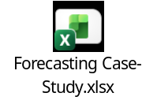

Problem Statement
Forecast next 8weeks of sales for each state using historical data.
Your solution must:
- Handle missing dates / missing values (if any)
- Handle seasonality & trend
- Automatically select the best performing model
- Serve predictions via API

Mandatory Models to Implement
Train and compare at least:
- ARIMA / SARIMA
- Facebook Prophet
- XGBoost (with lag features)
- LSTM (deep learning)

Feature Engineering (critical part)
You must create:
- Lag features (t-1, t-7, t-30)
- Rolling mean / std
- Day of week, month, holiday flag
- Train / validation split using time series logic (no leakage)

